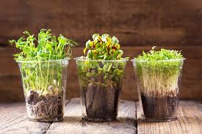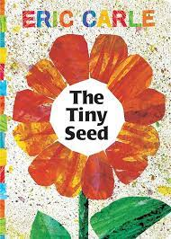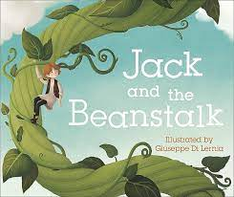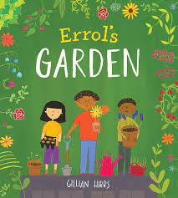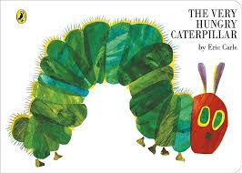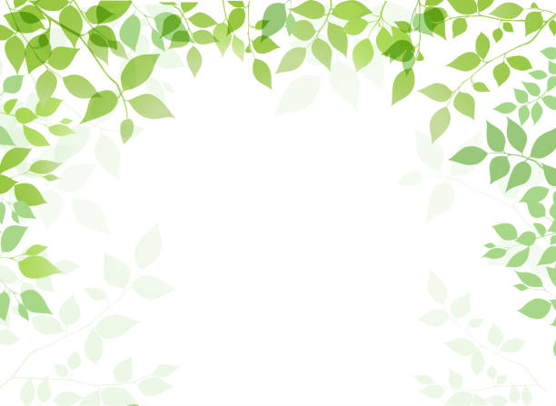

**Experiences**

We will grow our own seeds and beans.

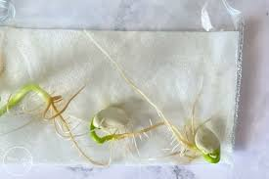

**Key Vocabulary**

Plants, grow, soil, sunlight, flower, water, leaves, stem, egg, change, observe.

*Words I will learn –*

Life cycle – the different stages of life for a living thing.

Cocoon/chrysalis– The hard casing during the transition stage from caterpillar to butterfly.

Roots – The parts of a plant that attaches it to the ground.

**Life cycles we will learn about:**

Key Texts

Reception Knowledge Organiser

Spring 2 Lets’ Grow!

**Sticky Knowledge**

*By the end of EYFS I will know…*

* Plants need sun light, soil, and water to grow.
* Plants die if they do not have enough water.
* Caterpillars hatch from eggs and turn into butterflies.

*I will be able to …*

* Explain how to grow a plant based on first-hand experience growing cress and beans in class.
* Talk about how creatures grow and change throughout their lives with a focus on the life cycle of a butterfly.